**Line W Update**

06/28/2017

**How can age and oxygen become decoupled?**

Age and oxygen are typically expected to be strongly negatively correlated in the ocean interior (ventilated regions?). Under what conditions does this negative relationship bread down and even reverse?

Hypothesis is that age ad oxygen become decoupled when the flow is dominated by mixing as opposed to advection.

**Results – Model Age-Oxygen Relationship.**

ESM2Mc model output along Line W suggests a region in the ocean interior where this relationship is reversed (Figure 1). The positive correlation region lies on neutral density surface γn = 27.0. This region lies just below the minimum in the oxygen climatology (Figure 1 (b)) and just above the maximum in age climatology (Figure 1 (c)).

HD:RESEARCH:chapter3:code:sandbox:ESM2Mc_NAtl:correlation_clim_on_linew.pdfTo examine this positive correlation structure, the age climatology, oxygen climatology, and correlation interpolated to neutral density surfaces are shown in Figures 2-4.

Figure 1: (a) Pearson correlation coefficient for age vs oxygen on Line W. (b) Oxygen climatology and (c) age climatology on Line W.

HD:RESEARCH:chapter3:code:sandbox:ESM2Mc_NAtl:age_clim.pdf

Figure 2: Age climatology interpolated to various neutral density surfaces.

HD:RESEARCH:chapter3:code:sandbox:ESM2Mc_NAtl:o2_clim.pdf

Figure 3: Oxygen climatology interpolated to various neutral density surfaces.

HD:RESEARCH:chapter3:code:sandbox:ESM2Mc_NAtl:correlation.pdf

Figure 4: Correlation between age and oxygen interpolated to various neutral density surfaces.

**Positive correlation region on Line W seems to occur in a relatively high-age and low-oxygen tongue that extends from the Southern edge of the subtropical gyre.** Oxygen and age climatologies do not suggest that this positive correlation region is dynamically related to the Southern flowing waters from the Labrador Sea?

Vertical profiles of age and oxygen climatologies along Line W (Figure 1) suggest positive correlation could be attributed to vertical mixing. To explore this idea further, the vertical profile and vertical gradient **at distance = 600km** is shown in Figure 5 (note this distance is chosen because it aligns with the maximum of positive correlation along Line W).

Still trying to interpret the vertical gradient figure (Figure 5(b)). Dashed lines show the approximate upper and lower bounds of positive correlation region. Positive correlation region appears to be where the vertical gradients do not diverge – age gradient stays relatively constant while oxygen gradient increases.

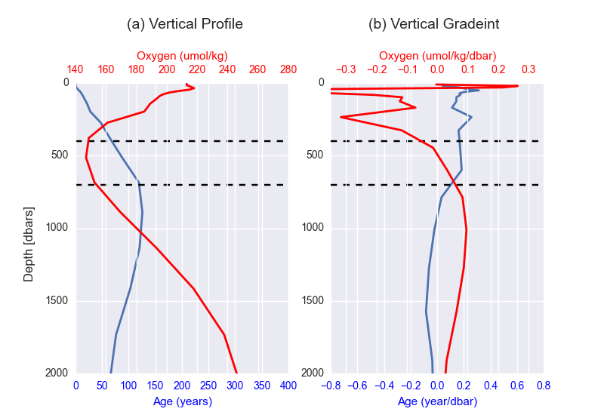

Figure 5: (a) Vertical profile and (b) vertical gradient of age and oxygen climatologies at distance = 600km along Line W. Dashed black lines designate approximate upper and lower bounds of positive correlation region.

**Conclusions**

* Positive correlation region along Line W occurs on neutral density surface γn = 27.0 – just above maximum in age climatology and just below minimum in oxygen climatology.
* Positive correlation region does not appear to be related to lateral mixing, either in the zonal or meridional directions (?).
* Vertical mixing likely explains positive correlation, but still working to show this.